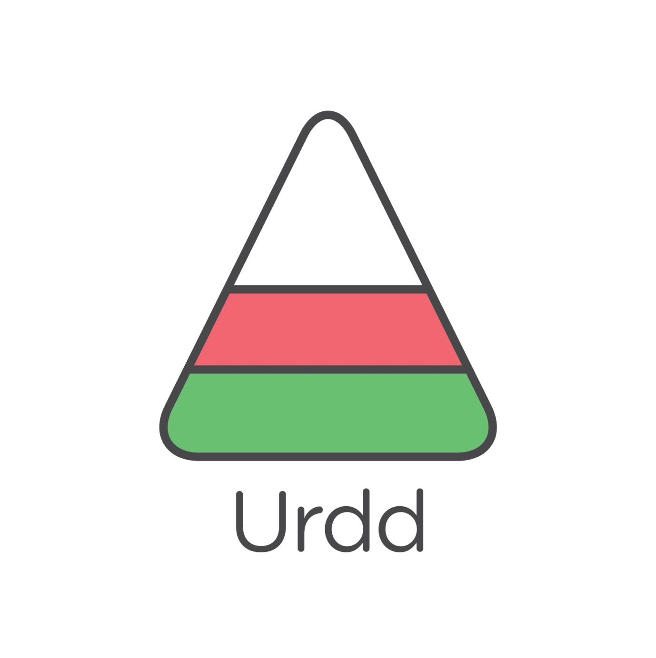

1922

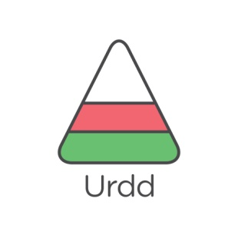

1938



1946



1947



1956



1960



1970



1983



2002



Heddiw

