Awgrymiadau o negeseuon cyfryngau cymdeithasol #Heddwch2021 i gefnogwyr ar Fai 18
Suggested #Heddwch2021 social media messages for supporters on May 18

Cyfrifon yr Urdd
Accounts to tag
Facebook: @urddgobaithcymru (Urdd Gobaith Cymru)
Twitter: @urdd
Instagram: @urddgobaithcymru

Hashnod/hashtag: #Heddwch2021
Sicrhewch eich bod yn defnyddio'r hashnod i'n helpu gadw golwg ar ba mor eang mae’r neges yn cael ei rhannu, os gwelwch yn dda!
Please ensure you use the hashtag to help us keep track of how widely our message is shared - thank you!

Adnoddau, lluniau ag ati ar gael yma:
Resources and images are available here:
https://www.urdd.cymru/cy/neges-heddwch-eleni/adnoddau/

Lluniau = Pictures
Byddem wrth ein bodd pe gallech gynnwys llun ohonoch chi'ch hun, eich myfyrwyr a/neu gefnogwyr eraill yn gwneud y symbol ‘=’ gyda’ch breichiau fel y lluniau isod. Rydyn ni am lenwi'r byd ar-lein gyda'r symbol yma o gydraddoldeb, felly cofiwch ddefnyddio'r hashnod #Heddwch2021 wrth rannu'ch lluniau ar Fai 18!
We would love it if you could include a photo of yourself, your students and/or other supporters making a similar pose to the images below, which is the equals symbol (=). We want to fill the virtual world with this symbol of equality, so remember to use the #Heddwch2021 hashtag when sharing your photos on May 18!

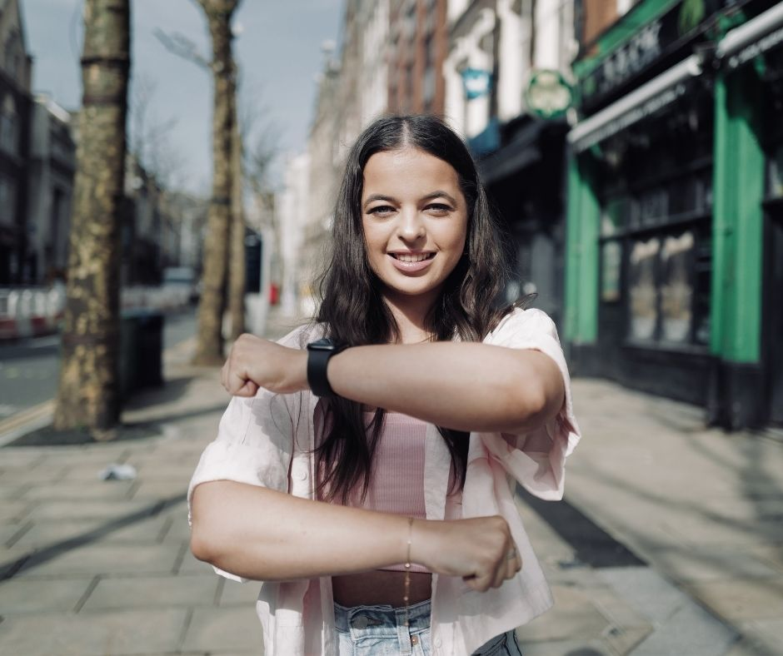

Awgrymiadau o negeseuon yn arwain at y 18fed o Fai – Diwrnod y Neges Heddwch
Suggested messages leading up to the 18th of May – The Day of the Peace and Goodwill Message
Twitter / Instagram | Facebook | Cynnwys / Accompanying content
Edrych ymlaen at Neges Heddwch yr @Urdd eleni - roedd un llynedd yn anhygoel! Cadwch lygad allan amdano ar Fai 18! 👀 #Heddwch2021  Looking forward to this year’s Peace Message - last year’s message was incredible! Keep an eye out on May 18! 👀 #Heddwch2021 | Edrych ymlaen at Neges Heddwch Urdd Gobaith Cymru eleni - roedd un llynedd yn anhygoel! Cadwch lygad allan amdano ar Fai 18! 👀 #Heddwch2021  Looking forward to this year’s Peace Message - last year’s message was incredible! Keep an eye out on May 18! 👀 #Heddwch2021 | Un o’r lluniau o’r ffolder adnoddau (linc uchod!)  One of the images from our resources (link above!)
Rydyn ni’n cefnogi Neges #Heddwch2021 pobl ifanc Cymru eleni. A fyddwch chi'n ymuno â ni ar Fai 18 ac yn rhannu eu neges bwerus am gydraddoldeb i ferched?  We’re supporting this year’s Peace Message from Wales’s young people. Will you be joining us on May 18 to share their powerful words about equality for women and girls? #Heddwch2021 | Rydyn ni’n cefnogi Neges #Heddwch2021 pobl ifanc Cymru eleni. A fyddwch chi'n ymuno â ni ar Fai 18 ac yn rhannu eu neges bwerus am gydraddoldeb i ferched?  We’re supporting this year’s Peace Message from Wales’s young people. Will you be joining us on May 18 to share their powerful words about equality for women and girls? #Heddwch2021 | Un o’r lluniau o’r ffolder adnoddau (linc uchod!)  One of the images from our resources (link above!)

Awgrymiadau o negeseuon ar y 18fed o Fai – Diwrnod y Neges Heddwch
Suggested messages for your socials on the 18th of May – The Day of the Peace and Goodwill Message
Ar y diwrnod, bydd ein fideo wedi ei binio ar dop ein cyfrifon cymdeithasol fel ‘pinned post’ o 8yb.
On the day, our video will be available to find as the pinned post on our socials from 8am.

Twitter / Instagram | Facebook | Cynnwys / Accompanying content
“Mae hyn yn fwy na hashnod. This is more than a hashtag.”  Am neges hynod o bwerus gan bobl ifanc Cymru. A very powerful message from the young people of Wales. #Heddwch2021 | “Mae hyn yn fwy na hashnod. This is more than a hashtag.”  Am neges hynod o bwerus gan bobl ifanc Cymru.  A very powerful statement from the young people of Wales as they share their annual Peace and Goodwill Message. #Heddwch2021 | Rhannu’r fideo neu ‘quote-tweet’ o gyfrif Urdd Gobaith Cymru NEU llun ohonoch yn gwneud symbol ‘=’ gyda’ch breichiau.  Quote-tweet or share the video from Urdd Gobaith Cymru’s account OR a photo of you doing the ‘=’ symbol with your arms.
Cymerwch funud i wylio’r neges anhygoel yma gan bobl ifanc Cymru am gydraddoldeb i ferched.  Rydym ni’n cefnogi’r neges ac yn sefyll gyda chi, @Urdd! #Heddwch2021  Take a moment to listen to this powerful message from the young people of Wales about equality for women and girls.  We support this message and stand with you, @Urdd. #Heddwch2021 | Cymerwch funud i wylio’r neges anhygoel yma gan bobl ifanc Cymru am gydraddoldeb i ferched.  Rydym ni’n cefnogi’r neges bwerys hyn ac yn sefyll gyda chi, Urdd Gobaith Cymru! #Heddwch2021  Take a moment to listen to this powerful message from the young people of Wales about equality for women and girls.  We support this message and stand with you, Urdd Gobaith Cymru. #Heddwch2021 | Rhannu’r fideo neu ‘quote-tweet’ o gyfrif Urdd Gobaith Cymru NEU llun ohonoch yn gwneud symbol ‘=’ gyda’ch breichiau.  Quote-tweet or share the video from Urdd Gobaith Cymru’s account OR a photo of you doing the ‘=’ symbol with your arms.
"Hawliau merched yw hawliau dynol. Hawliau dynol yw hawliau merched. Ni allwn achub y byd os nad yw’r byd yn gyfartal.”  Diolch yn fawr iawn i bobl ifanc Cymru am rannu’r neges hyn; rydyn ni yn eich cefnogi ac yn sefyll gyda’n chwiorydd. #Heddwch2021  “Women’s rights are human rights. Human rights are women’s rights. We can’t save the world until the world is equal.”  A very powerful message from the youth of Wales; we support their words and stand with our sisters around the world. #Heddwch2021 | "Hawliau merched yw hawliau dynol.  Hawliau dynol yw hawliau merched.  Ni allwn achub y byd os nad yw’r byd yn gyfartal.”  Diolch yn fawr iawn i bobl ifanc Cymru am rannu’r neges hyn; rydyn ni yn eich cefnogi ac yn sefyll gyda’n chwiorydd. #Heddwch2021  “Women’s rights are human rights.  Human rights are women’s rights.  We can’t save the world until the world is equal.”  A very powerful message from the youth of Wales; we support their words and stand with our sisters around the world. #Heddwch2021 | Rhannu’r fideo neu ‘quote-tweet’ o gyfrif Urdd Gobaith Cymru NEU llun ohonoch yn gwneud symbol ‘=’ gyda’ch breichiau.  Quote-tweet or share the video from Urdd Gobaith Cymru’s account OR a photo of you doing the ‘=’ symbol with your arms.
Ers 99 mlynedd, does dim un rhyfel na pandemig wedi rhwystro pobl ifanc Cymru rhag rhannu eu Neges Heddwch gyda’r byd.  Dyma neges eleni. #Heddwch2021  For 99 years, young people in Wales have shared an annual Peace Message with the world through thick and thin, wars and pandemics.  Here’s this year’s message. #Heddwch2021 | Ers 99 mlynedd, does dim un rhyfel na pandemig wedi rhwystro pobl ifanc Cymru rhag rhannu eu Neges Heddwch gyda’r byd.  Dyma neges eleni. #Heddwch2021  For 99 years, young people in Wales have shared an annual Peace Message with the world through thick and thin, wars and pandemics.  Here’s this year’s message. #Heddwch2021 | Rhannu’r fideo neu ‘quote-tweet’ o gyfrif Urdd Gobaith Cymru NEU llun ohonoch yn gwneud symbol ‘=’ gyda’ch breichiau.  Quote-tweet or share the video from Urdd Gobaith Cymru’s account OR a photo of you doing the ‘=’ symbol with your arms.
Rhannwch hwn, bawb – mae neges pobl ifanc Cymru am gydraddoldeb i ferched yn llawer rhy bwysig i’w anwybyddu. #Heddwch2021  This is too important to ignore. Please share this critical message from Wales’s young people about equality for women as far and wide as possible! #Heddwch2021 | Rhannwch hwn, bawb – mae neges pobl ifanc am Cymru am gydraddoldeb i ferched yn llawer rhy bwysig i’w anwybyddu. #Heddwch2021  This is too important to ignore. Please share this critical message about gender equality from the youth of Wales as far as wide as possible! #Heddwch2021 | Rhannu’r fideo neu ‘quote-tweet’ o gyfrif Urdd Gobaith Cymru NEU llun ohonoch yn gwneud symbol ‘=’ gyda’ch breichiau.  Quote-tweet or share the video from Urdd Gobaith Cymru’s account OR a photo of you doing the ‘=’ symbol with your arms.
Eleni, fel bob blwyddyn ers 1922, mae pobl ifanc Cymru wedi rhannu neges o heddwch gyda’r byd.  Mae neges eleni wedi ei gyfieithu i 60 iaith, gan gynnwys [EICH IAITH].  Rydyn ni’n cefnogi eu galwad am gydraddoldeb i ferched. #Heddwch2021  Today, like every year since 1922, the young people of Wales have shared a message of peace with the world.  This year their message is available in 60 languages including [YOUR LANGUAGE].  We support their call for equality for women and girls. #Heddwch2021 | Eleni, fel bob blwyddyn ers 1922, mae pobl ifanc Cymru wedi rhannu neges o heddwch gyda’r byd.  Mae neges eleni wedi ei gyfieithu i 60 iaith, gan gynnwys [EICH IAITH].  Rydyn ni’n cefnogi Neges Heddwch 2021 a galwad Urdd Gobaith Cymru am gydraddoldeb i ferched. #Heddwch2021  Today, like every year since 1922, the young people of Wales have shared a message of peace with the world.  This year their message is available in 60 languages including [YOUR LANGUAGE].  We support this Peace and Goodwill Message and Urdd Gobaith Cymru’s call for equality for women and girls. #Heddwch2021 | Rhannu’r fideo neu ‘quote-tweet’ o gyfrif Urdd Gobaith Cymru NEU llun ohonoch yn gwneud symbol ‘=’ gyda’ch breichiau.  Quote-tweet or share the video from Urdd Gobaith Cymru’s account OR a photo of you doing the ‘=’ symbol with your arms.

