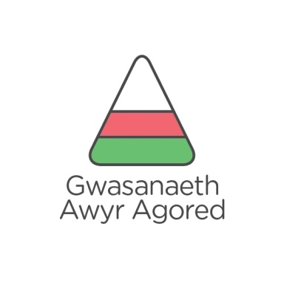

GWOBR DUG CAEREDIN DUKE OF EDINBURGH AWARD

GRŴP/GROUP:
HYFFORDDIANT HANFODOL / ESSENTIAL TRAINING
Aelodau / Members | Cymorth cyntaf / First Aid | Iechyd a Diogelwch / Health & Safety | Cynllunio teithiau a Chyfeiriannu / Navigation & route planning | Gwersylla, offer ac hylendid/ Camp craft, equipment & hygiene | Bwyd a Choginio / Food and cooking | Côd Cefn Gwlad / Countryside code | Arsylwi, cofnodi a chyflwyno/ Observation, recording & presentation | Adeiladu Tîm /Teambuilding | Hyfedredd Teithio / Proficiency of travel | Sylwadau ychwanegol / additional comments
1>
2>
3>
4>
5>
6>
7>

ARWEINYDD/LEADER:

Datganiad o gywirdeb/Declaration of accuracy:

