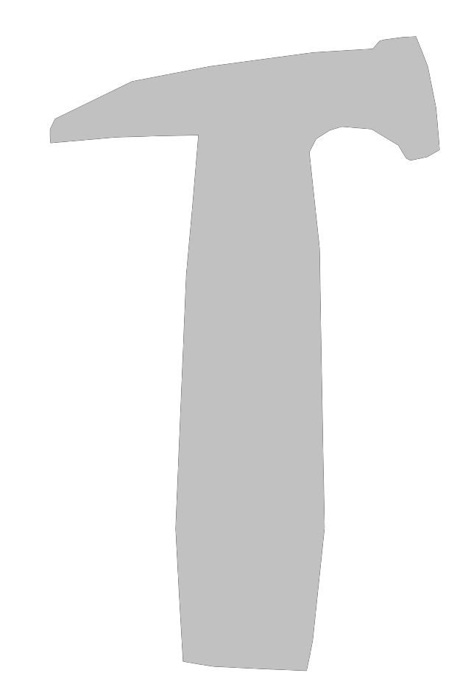

Taflen 3 : Bwrw’r Wal i Lawr

*\*Atgynhyrchwyd trwy ganiatâd caredig Oxfam:* [*w**ww.oxfam.org.uk/education/resources/international-womens-day*](http://www.oxfam.org.uk/education/resources/international-womens-day)



