Case Study 2
Hadiqa Bashir: Campaigning against Early Marriage
(Primary / Secondary)

What’s happening?
More than 650 million women who are married in the world today, got married whilst they were still children. Each year, at least 12 million girls (1 in 5) girls marry before reaching the age of 18 years old. In less developed countries, the number doubles: 40% marry before they are 18 years of age, and 12% before 15 years of age. The practice is more prevalent in areas where there’s a humanitarian crisis (where girls are regarded as a burden on the family) and in war torn areas. (Source UNICEF).
Early marriage and forced marriage is considered as an abuse of human rights. It’s a practice that’s a threat to girls' safety, meaning that they are unable to make decisions about their own lives. It interrupts their education and prevents them from participating fully in a country’s society, economy and politics. Early marriage often means that girls get pregnant early, with a higher risk of dying whilst giving birth.
For more information, go to: https://www.ohchr.org/EN/Issues/Women/WRGS/Pages/ChildMarriage.aspx

Introduction:
In order to present this subject, you could show this short video: https://youtu.be/3ow52D-oBuA which shows what happens to Tuni, an imaginary girl in a developing country.
After watching the video, you could ask:
- How was Tuni's life at the beginning of the film?
- How are things changing?
- How do you think her life will be now? What won't be possible for her? What is the worst that can happen?
- Is there anything that she could do to change the situation? (Some girls run away or kill themselves in order to avoid getting married against their will)

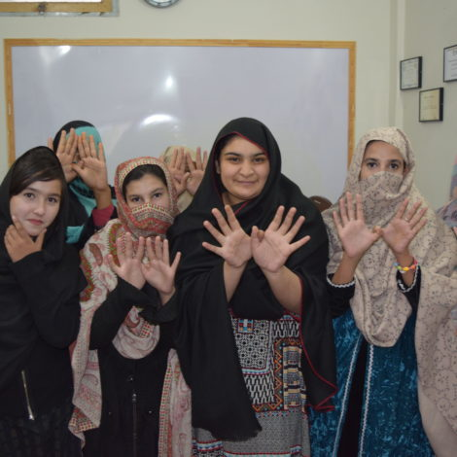
Case Study: Hadiqa Bashir – Campaigning against Early Marriage in Pakistan:
Tell your pupils about Hadiqa:
"Now 17 years old and living in Swat in Pakistan (the same area where Malala Yousafzai was born), Hadiqa Bashir has been campaigning against child marriage since she was 14 years old.
Llun o wefan FRIDA - Gronfa Rhyngwladol i Ffeministiaid Ifanc
When she was 11 years old, a man – a taxi driver – asked her to marry him. Both her father and grandfather were in favour of the proposal. Fortunately, she has an uncle who’s a campaigner for human rights, and he persuaded the family that marrying children is illegal and contrary to human rights. Hadiqa was able to continue her education and life.
Hadiqa had a friend who was forced to marry when she was only 7 years old. After marrying, she stopped coming to school. One day, Hadiqa and her friends invited this girl to a party. They were shocked to see that she was covered in bruises.
Because of her experiences and through witnessing the experiences of other girls, Hadiqa decided that she had to do something. This is why she set up the 'Girls United for Human Rights ' Group – a group campaigning for women’s rights, and especially against girls marrying early. Hadiqa and her friends go from door to door, talking to mothers, fathers, families – all about the negative effects of early marriage on children's health and well-being. She has spoken to community groups and politicians, and has campaigned to raise the legal age to marry to 18. The group has also influenced religious leaders, asking them to talk about the rights of girls when they preach. "It’s not possible to keep women silent for a long time" says Hadiqa. "There’s a desire for change amongst our young people." Despite threats from extremist groups, she continues with her campaign.

Discuss:
- Why do some communities such as Swat in Pakistan continue the practice of marrying girls early?
- What methods have Hadiqa and his friends used to persuade people that marrying young and forced marriage is wrong?

Response:
- Imagine that you are Hadiqa. Write a page from your diary describing your feelings when your dad told you that you had to marry the taxi driver when you were 11 years old. Describe what happened afterwards (advice and help from your uncle and reversing the original decision.)
- What about creating a drama or cartoon strip talking about the formation of the ' Girls United for Human Rights ' group, including the kind of conversations that they have with people on their doorstep to change their minds about marrying girls early.
- What about creating an exhibition or a short film about this problem and how to overcome it?

Action
- The problem of early and forced marriage also exists in the UK. Find out more information about this. There are some sources here:
https://www.hrw.org/news/2018/09/06/ending-child-marriage-united-kingdom,
https://www.theguardian.com/society/2018/may/10/more-than-1000-cases-of-forced-marriage-in-uk-last-year-report-says
and you can read Temwa’s Story here: https://www.worldvision.org.uk/news-and-views/blog/2019/july/child-marriage-uk-malawi-brides-story/
- Arrange an event in your school/community to raise awareness of girls having to marry as children. You can show a film, tell Hadiqa’s story, or invite a speaker/talker.
- Write a letter to your local newspaper or do a radio interview to raise awareness of the problem and the fact that it still exists in the UK.
- Plan a campaign to put pressure on the UK/ Welsh Assembly Government to create change

You can write to your Member of Parliament or Assembly Member using the ' Write to Them ' website:www.writetothem.com/

Sources:
- ‘Girls to the Front’ – case studies from FRIDA (Hadiqa and the groups’ stories are on page 14)
- A talk by Hadiqa (unfortunately, not in English) : https://www.youtube.com/watch?v=kN881ZzaQhQ
- ‘Girls United for Human Rights’ website https://youngfeministfund.org/grantees/girls-united-for-human-rights-2/
- Article on Hadiqa on the Vogue website: https://www.vogue.in/culture-and-living/content/gen-z-political-activists-who-are-determined-to-save-the-world

