What does Girls’ Empowerment Mean?
What can we do about it?
(Primary)
Aims of these Activities:
These activities should be run after the initial Assembly on Empowering Girls. They aim to:
- Support children in understanding the theme more deeply, to think critically and to be able to discuss matters for themselves
- Introduce options for taking further action on the theme, including creative activities and taking part in campaigns in school, the local community and beyond.
*Many thanks to ActionAid for their kind permission to reproduce some of their educational resources on gender inequality (https://www.actionaid.org.uk/school-resources/search/s/topic/0-2363)

- Initial Activities:
See the initial activity on inequality suggested by ActionAid (Sheet 1).
Run the activity with sweets (or fruit) with the pupils – also the activity with money if you wish. Use these activities to encourage your pupils to discuss inequality and how it makes people feel.
You may need to have further discussion about the meaning of the word ‘inequality’. The main point for pupils will more than likely be fairness. Nobody should be treated differently because of their gender, age, race, background, etc.
Explain that you will be looking at inequality between boys and girls today – and considering some actions they can take to express their opinions about injustice.

2. What do we mean by gender inequality?
See the sheet entitled ‘What is Gender Inequality?’ by ActionAid (Sheet 2). You can either:
- Cut up the statements and ask the children to work in groups and discuss whether they think they are true or false; or
- Use the statements to do a Values Continuum. Read out the statements one at a time, and ask the children to move to one end of the room or the other, according to whether they think the statements are true or not.
When the pupils have looked at / heard all the statements, you can reveal that they are all true. Ask them:
- How does this make you feel?
- Do some statements stand out for you? Why?

3. The right to go to school: (ActionAid – Sheet 3):
Look at the statistics and the quotes by girls saying why it’s important to them to go to school.
In a group or groups, discuss:
- Why is it important for girls to go to school?
- What are the possible consequences if this doesn’t happen?
- What can we do to raise awareness of this issue, and to create change?
If you wish you can also discuss this problem using a ‘Why, why, why’ chain:
Give each group of pupils a large piece of paper. Starting at the left, they should ask the question: ‘Why is it important for girls to go to school?’ They should then continue to ask the question ‘why’, moving across the paper to the right as below. This will help them to see the impact of the problem on girls, their families and society in general.
Why?
Why?
Why?
Why is it important for girls to go to school?

Why?
Why?
Why?

4. Looking at gender stereotypes:

a) The aim of this activity is to look critically at some common ideas in our culture / society about the roles or boys and girls.

In groups, ask the children to look at the quotes on the cards (Sheet 4: The Role of Boys and Girls) and discuss:
- What are the ideas / stereotypes behind these situations?
- In what ways can they restrict girls and the choices they can make in life?
- Is this also true of boys?
- What can we do to challenge stereotypes?
Discuss your ideas as a whole group (perhaps in the form of circle time) – and decide on one thing you can do as a class to reduce sterrotypes and prejudices on this theme.

b) Ideas about Jobs:
In groups, ask the pupils to draw pictures of the following jobs:
- Nurse
- Doctor
- Fire-fighter
- Scientist
- Astronaut
- Politician
- Gardener
- Artist
Ask the groups to share their drawings. How many drew boys / girls for the different jobs? What does this tell us about the expectations of society? If a girl wants to train for a career where the majority are men, is this difficult? Why? How could society make things easier?

c) The world of advertising:
Ask the children to look at adverts (in magazines, on the TV, on the internet, on billboards ……) for products for men / women – e.g. shampoo, perfume / deodorant, shoes, clothes, cars …………
Ask them to analyse the adverts according to:
- Their appearance (how do they look?)
- The atmosphere that’s invoked (how do they ‘feel’? What comes to mind when looking at them / hearing them?)
- The language used (what sort of nouns / adjectives? What associations do these words have?)
As a class – share the results of your research. What is similar and what is different about the adverts that are aims at men / women? What does this tell us about the ideas / prejudices of our society? What can we do to challenge these stereotypes?

5.Case studies:

There are two case studies which are suitable for primary age pupils – one that looks at girls’ right to an education, and one which highlights a campaign against girls marrying early in Pakistan.

You can use these case studies to understand the problems which face girls in more depth, but also as a source of inspiration by considering what girls themselves have done to campaign for change – sometimes at their own personal risk.

6. What can we do? Taking action!

An important aspect of the Message of Peace and Goodwill this year is the aim to encourage as many young people as possible in Wales and beyond to express themselves creatively on the theme of Empowering Girls in the period leading up to 18th May – also to encourage young people to take action and to share what they have done.

Some ideas are suggested below.

- Look at the case studies which accompany this pack. What issue is of concern to you?
  - Plan a campaign with your friends, using the ideas at the end of the case studies.
  - Be creative: you can create an exhibition in your school or local library; write poems, stories or songs; express yourself through artwork …..
  - Contact people you think can help you to make a change – e.g. politicians, celebrities ….. to support you in your campaign!

- Choose a girl / woman who is an important role model for you. It can be someone contemporary or a historical figure – e.g. Malala Yousafzai, Greta Thunberg, Rosa Parks, Tanni Grey Thompson….. Remember that it can be someone close to home. (See ‘100+ Welsh Women here: http://www.100welshwomen.wales/)
  - With your friends, put an exhibition together or create a project about women who have achieved amazing things and changed the world!
  - Your exhibition / project can include creative writing (poems / articles / blogs, stories ……); art (pictures / sculptures / photos); creating digital presentations or films
  - Invite people to come and see your work – e.g. local councillors / governors/ politicians / celebrities….

- Invite a prominent woman to your school to give a talk or make a presentation – e.g. someone from the world of sport / drama / politics (See ‘100+ Welsh Women here: http://www.100welshwomen.wales/)
  - Organise a whole-school assembly
  - Prepare questions for an interview, in order to discover more about her experiences and the challenges she has overcome
  - Share your interview with a wider audience (with permission) through blogs or social media

- For International Women’s Day (8th March):
- Encourage as many people in your school to make a pledge to empower girls, using the WEN Wales Pledge Card.
- Hold an event on 8th March – e.g. a speaker, a café, a book fayre, a discussion group, a film ….
- Invite members of your community to your event and ask them to support your campaign!

- On 18th May (the day on which the Message of Peace and Goodwill will be broadcast):
  - Hold a special Assembly in your school to share the Message
  - Respond to the Message through email and on social media
  - Share the Message with friends in Wales and abroad, and encourage them to create and share responses to the Message.
Use the hashtag: #Heddwch2020
Whatever you do, remember to share it with the Urdd. You can do this by using @Urdd / @Urddgobaithcymru

Other Hashtags to use:
#WelshHeroine #100WelshWomen
#IWD2020
#HeforShe

For other ideas go to:
- International Women’s Day website: https://www.internationalwomensday.com/School-Resources
- Women’s Equality Network Wales (WENWales) website: https://wenwales.org.uk
- HeforShe Action Kit (UN Women) : https://www.heforshe.org/sites/default/files/2018-09/HeForShe_Action_Kit_Individuals.pdf

Sources:
Action Aid – school resources: https://www.actionaid.org.uk/school-resources/search/s/topic/0-2363
Resources for International Women’s Day: https://www.internationalwomensday.com/School-Resources
WENWales Resource Pack: https://www.internationalwomensday.com/School-Resources
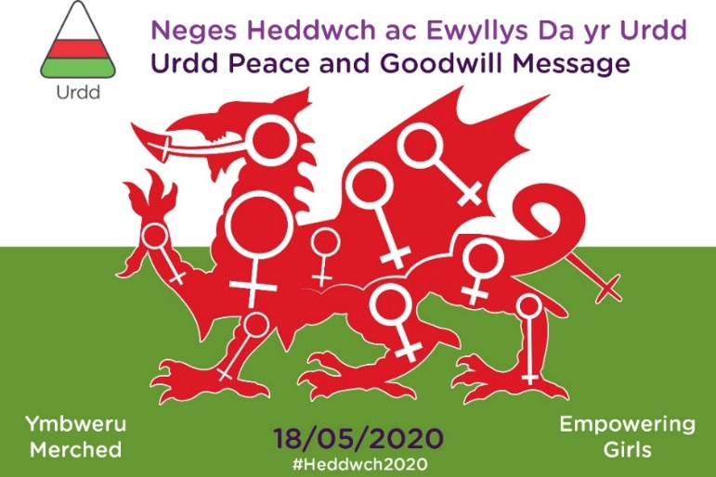

Remember to use the hashtag: #Heddwch2020

