Case Study 3
Campaigning for Girl’s health
(Secondary)

What’s happening?
Sexual and reproductive health is important for young people who are maturing, in order to understand what is happening to their bodies, how to stay physically and emotionally healthy, and how to form equal relationships based on friendship and respect. While this is something that happens as part of education in the UK, this is not universally the case – with far-reaching consequences for young people – especially girls.
- In areas where sexual and reproductive health is unavailable, sexually transmitted diseases such as HIV and AIDS spread more readily. Girls are more likely to become pregnant early, which means that they cannot continue with their education.
- A lack of understanding about natural physical phenomena such as menstruation causes problems for girls, and a lack of resources means that it’s difficult to ensure cleanliness and health.
- In a survey done in India in 2014, up to 42% of women did not know about sanitary towels. The majority of girls were scared and worried about their first period.
- In 2018, 1/3 women across the world did not have access to a toilet that worked, nor to clean water.
Menstrual hygiene is not a priority for many governments in developing countries. In 2014, Menstrual Hygiene Day was celebrated for the first time on May 28. This provides an opportunity to raise awareness of the problem and potential solutions, and to intervene for change.

Introduction:
* Please note that the content of this unit can be sensitive. Teachers will also need to make a decision about whether the unit is suitable for boys and girls together, or separately. For these reasons, the unit starts with an introductory activity, suitable for a mixed group.

Introductory Activity:
Relationships and Sexuality Education in Schools:
The Welsh government has just consulted on how Relationships and Sexuality Education should look in the new curriculum. The purpose of this activity is to support young people to discuss their ideas about this. What’s important to them? What do they need to know, and how would they like to learn? How can boys and girls work together to achieve gender equality?
a) Explain that the Welsh Government has suggested the following themes as the important ones that young people should consider as part of Relationships and Sexuality Education between the ages of 5 and 18 years:
- Values, rights, culture and sexuality;
- Understanding gender;
- Violence and staying safe;
- Skills for health and well-being;
- The body and its development;
- Sexuality and sexual behaviour; and
- Sexual and reproductive health.
b) In small groups, ask the pupils to consider:
‘If you had to consider which of these elements is most important, how would you prioritise them? Which ones would come first? Are there elements that are not so important? Why?
You can use the ' Diamond 9 ' method to answer these questions:
The most important
1. Discuss as a group which element is most important. This is what goes at the top.
2. Discuss each of the other elements in turn. Where should they be and why?
3. Remember it’s important to discuss as a group and listen to everyone's views. It's OK to change your point of view if necessary!

The least important

c) Once the prioritisation has taken place, divide the pupils into 8 groups, giving one of the above themes to each one. Now, ask them to consider:
- Why is this theme important?
- When would you introduce this theme (for what age)?
- Who should lead the learning? (e.g. teacher/person from outside/pupils – a combination of all three?)
- How should the theme be delivered (and what doesn't work)?
- Should this theme be introduced to boys and girls separately, or to both together? Why?
- What would you like to gain from this theme?
Ask the pupils to make a record of their discussion to feed back to the staff at the school who are responsible for Relationships and Sexuality Education.

Further activities:
You can now give the pupils a choice as to what they want to do next.
- Some pupils will look at a case study about girls and boys in Uganda running a programme to give sexual and reproductive health education to their peers.

- The other group will work on planning input into Relationships and Sexuality Education for their peers OR on planning a campaign to raise awareness about inequality between boys and girls.

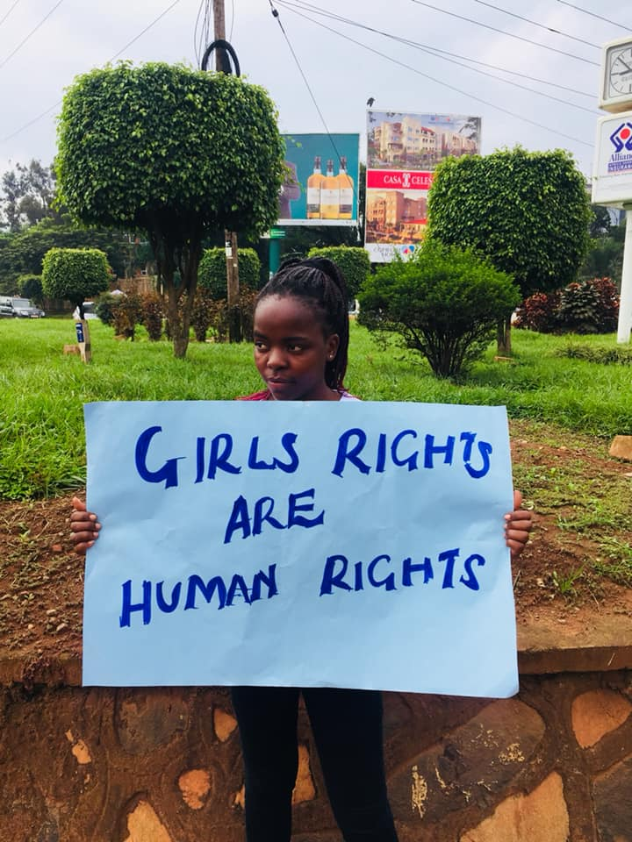
Case Study: ‘Hands of Hope’ – Menstrual Hygiene for Women in Uganda.
Llun o dudalen Facebook 'Hands of Hope'
Joan Khabelle set up the ' Hands of Hope ' initiative because she noticed that girls in her community in Uganda did not even have basic information about menstruation and about sexual and reproductive health. They were ill-treated by their families simply because they were girls. She wanted to create an initiative that would empower girls, and give them skills.
Today, 'Hands of Hope' offers a range of programmes for young people in schools and also in the community. These include girls and young mothers learning skills to help them become financially independent. One of the projects is to teach girls to make washable and healthy sanitary towels using local materials. This has changed the lives of some of the girls, who could not afford to buy towels.
'Hands of Hope ' works with girls aged between 10 and 24. On reaching 24, girls are able to become peer educators, further sharing their experiences and skills. Boys also take part in the programmes – by helping them to run smoothly and by transferring particular skills – e.g. how to earn a living.
The work has not been without challenge. A number of people in the community have been suspicious about what the girls are doing, as it challenges traditional ideas and practices. To overcome these problems, they are working collaboratively with community leaders to try and persuade them about the value of the initiative.
For further information, go to: https://www.facebook.com/hohiuganda/

Discuss:
- What were the difficulties faced by girls in Joan Khabelle’s community?
- How has the 'Hands of Hope ' project supported them?
- What has hindered their work, and how have they overcome the difficulties?
Response:
- Imagine that you are a girl in Joan Khabelle’s community. Write a page from a diary describing your feelings as you start menstruating for the first time. What have people told you, and what are your fears? What are the effects of menstruation for you (e.g. having to stay home from school....)

- Why not create an exhibition about the work of ' Hands of Hope ' which shows the scale of the problem, what can be done to improve the sexual and reproductive education of girls and boys globally, and how this helps to empower women and create equality.

Action
- Arrange an event in your school / community to raise awareness about the importance of sexual and reproductive education for girls and boys, including menstrual hygiene. (You can do this on 28 May – or on another date such as 8 March – International Women's Day)

- Write a letter to your local newspaper or do a radio interview to raise awareness of the problem and what people can do to support groups such as 'Hands of Hope '.

- Plan a campaign to put pressure on the UK/Welsh Assembly Government to create change.

You can write to your Member of Parliament or Assembly Member using the 'Write to Them ' website: www.writetothem.com/

Sources:
- A UK thesis about women's rights to sexual and reproductive education, September 2019: https://www.gov.uk/government/news/healthcare-for-everyone-must-prioritise-womens-sexual-and-reproductive-health-and-rights-says-uk-at-un-general-assembly
- Blog about the importance of menstrual health: https://soapboxie.com/world-politics/Menstrual-Health-Education-in-Developing-Countries-and-Why-It-Matters
- Menstrual Sanitation Day: https://www.sacraza.com/single-post/2019/05/28/International-WHO-Menstrual-Hygiene-Day#!
