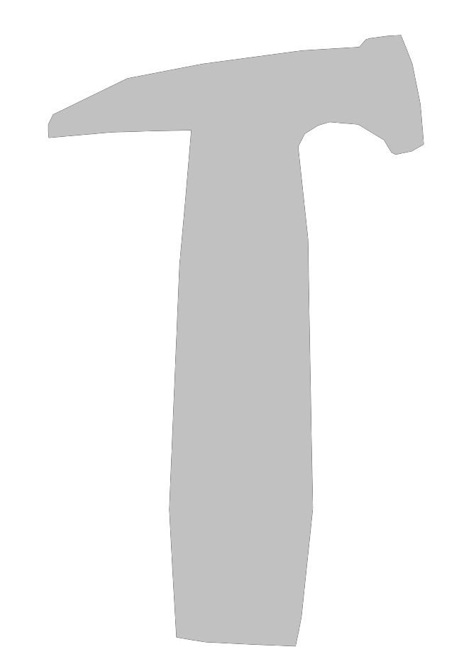

Breaking down the Bricks

*\*Reproduced by kind permission of Oxfam:* [*www.oxfam.org.uk/education/resources/international-womens-day*](http://www.oxfam.org.uk/education/resources/international-womens-day)



