Case Study 1
Children suffering due to war (Yemen)
(Primary / Secondary)

What’s happening?
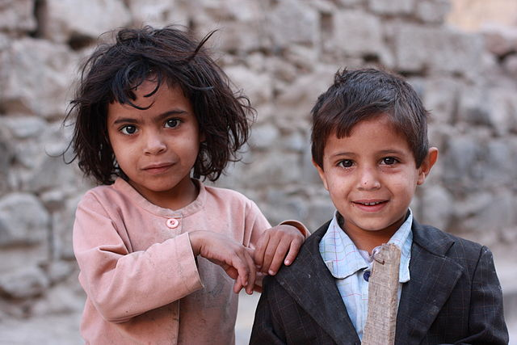
For three years, Yemen – the poorest country in the Middle East – has suffered a civil war between the government and the Houthi rebels. The intervention of other countries has intensified the conflict; countries (including Britain, which sells arms to Saudi Arabia) have been selling weapons to both sides. Ordinary people have been worst hit due to the war – with women and children suffering greatly. It is estimated that 60,000 people have been killed in the last two years. Thousands of children have died of malnutrition. The situation is now regarded as a humanitarian emergency.
By yeowatzup - San'a, Yemen, CC BY 2.0, https://commons.wikimedia.org/w/index.php?curid=24520835
As part of a special project, UNICEF Canada worked with children from Yemen to create short films outlining how the war has affected their lives. Their stories are summarised below.

Story 1: Unable to go to school due to the war
In October 2018, Mohammed (aged 10) went to the school to register for the new year. However, he was turned away. The school was closed as the teachers had not been paid.
According to Shadi, who created the film: “Mohammed was very disappointed that he was unable to go to school, but he’s not the only one. Many children in Yemen are in the same boat. Teachers are forced to seek other work in order to feed their families.”

Story 2: Coping with disability due to the war
Emad, aged 6, lives in Aden, in Yemen. He lost both his legs and a finger on his right hand when a missile hit his house. He has also suffered mentally due to his injuries. UNICEF has provided artificial legs for Emad, but he doesn’t like using them as he can move quicker without them, using his hands to move from place to place.
Emad dreams of a world in which all children can live in peace.

Story 3: Suffering loss due to the war
For her video project, Hajar Abu Baker, aged 12, decided to interview Zahra, who lost her seven-year-old son, Emran, in the war.
Emran had gone with his friends Afan and Abdul Salam to the mosque to fetch Afan’s father’s glasses when they were killed by a missile. "Emran’s death was a huge shock for me,” said Zahra. "He shone a light in the house, and I would rely on him as his father was ill.”
To Hajar, Emran, Afan and Abdul are 3 children out of the thousands who have lost their lives in the war.

Activities:
Research
- Primary: You can see the short films created about Mohammed, Emad and Zahra here: www.unicef.ca/en/blog/yemen-childs-story
- There are more facts about children in Yemen here, and information about Save the Children’s work supporting them: www.savethechildren.org/us/what-we-do/where-we-work/greater-middle-east-eurasia/yemen
- Secondary: You can learn more about the war in Yemen here: www.google.com/search?q=the+war+in+yemen+explained&oq=the+war+in+&aqs=chrome.0.69i59j69i57j0l2j69i65j0.2984j0j8&sourceid=chrome&ie=UTF-8 and here: https://www.bbc.co.uk/news/world-middle-east-44466574

Discuss
- What can be done to help children who are suffering due to war? Look at the websites of charities such as Save the Children and UNICEF to see what they are doing to support children in countries such as Yemen.
- How can pressure be exerted on governments (including Britain’s government) to stop selling arms to both sides, and to focus on encouraging everyone to discuss and find a solution?

Respond
- You are living in Sanaa, the capital of Yemen. Write a diary describing life there. Are you frightened? Have you lost members of your family/friends? What have you lost due to the war? What are you hopes for the future?

- Draw pictures in response to the stories about Mohammed, Emad and Zahra using the hashtag #heddwch2019 and then create a display with them in your school. Remember to share your images on social media using the same hashtag. You can take photos of your display and send them to the Urdd using heddwch@urdd.org.

- What about creating a film to raise awareness about the situation of children in Yemen? What is the aim of your film, and who is your audience?

Act
- Arrange an event in your school or community to raise money for a charity which supports children in Yemen.

- Write a letter to your local paper or conduct an interview on the radio to raise awareness about the way in which the children of Yemen are suffering due to the war. Encourage people to contribute towards charities to support them.

- Plan a campaign to put pressure on the UK government to stop selling arms to Saudi Arabia and to use its influence to encourage people to come together to discuss a peaceful resolution.

For some ideas, read about Save the Children’s campaign here: www.savethechildren.org.uk/how-you-can-help/show-your-support/campaigning-to-protect-children-in-yemen

You could also write to your Member of Parliament or your Assembly Member using the website ‘Write to Them’: www.writetothem.com/

