Case Study 2
Children in fear due to Knives (UK)
(Primary / Secondary)

What’s happening?
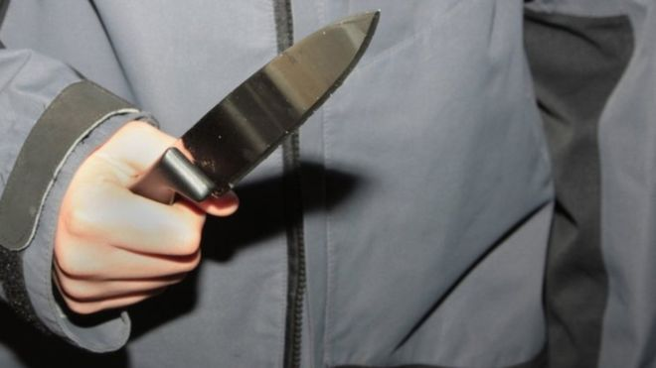
Public concern about knife crime has increased considerably recently due to the increase in the number of people killed or injured by knives – especially in London and other major English cities. Figures compiled by the Office of National Statistics show a sharp increase in the number of deaths attributed to knives in the United Kingdom between 2016/17 and 2017/18 – from 212 to 285. The biggest rise in the number of deaths has been among young men aged between 16 and 24.
Cymru Fyw, 28 November 2018
This problem isn’t confined to England. According to a report published by the police in Wales in November 2018, incidents of knife crime in Wales had increased by 25% in the year to June 2018. According to Dr Abdul Azil Ahmed from the Ethnic Youth Support Team: "There are two aspects to knife crime. Some carry knives in order to commit violent attacks and others carry knives to defend themselves because they feel the need to do so. The combination is toxic, and unfortunately, this is happening in Cardiff.”
The Youth Parliament survey of 13,000 young people in Cardiff found that knife crime was at the top of the list of concerns shared by young people.
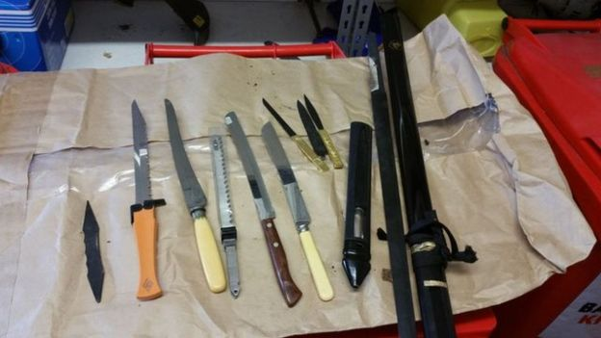
Everyone is aware of the problem itself, but there are different ideas about how to solve it. According to some, legislation should be strengthened to make it illegal to carry knives over 3 inches long and police should be given additional powers. Others refer to the damaging cuts which have ravaged youth services due to the economic situation. Everyone agrees that education is important. In Glasgow, the number of
Knives found by Gwent Police during a raid

knife crimes have been halved due to the development of a whole-community strategy.
However, whilst waiting for solutions from politicians, young people on the streets of England and Wales continue to fear for their lives.

Activities:
Research
Further information is available here:
- I-News: The Essential Daily Briefing, 6 March, 2019 - https://inews.co.uk/news/uk/uk-knife-crime-statistics-stabbing-numbers-london-explained/
- Cymru Fyw, 28 November 2018: www.bbc.co.uk/cymrufyw/46352438

- The Week Magazine, 29 November 2018: www.theweek.co.uk/crime/97620/how-to-solve-knife-crime
Discuss
Divide the class into two teams. According to Team A, the solution to knife crime is to strengthen the Law and ensure that there are more police on the streets. Team B believe that the problem would be solved by providing more services which support young people.
Give both teams time to develop their arguments, and then hold a debate.
Resources which provide guidance in holding a debate are available here: www.wcia.org.uk/global-learning/resources/debating-resources/

Respond
- How do you feel about knife crime? Frightened? Concerned? Helpless? Write a creative piece which explores your ideas about this issue. It can be a story, a poem or an essay.

- How about creating a poster about carrying knives which explores your concerns and your opinions about how the problem could be solved? You could do this individually or as a class. Who is your audience? What are your main messages? Remember to use the hashtag #heddwch2019 to further share your images on social media. You can also send photos of your poster to the Urdd using heddwch@urdd.org.

Act
On 15 March 2019, this letter was sent to the Metro newspaper in London:
I’m 11, put down your knives
I am 11 and commute through Penkridge and Birmingham every day – and every day, I have a fear of knife crime. There are addicts and alcoholics lurking everywhere. I feel sorry for them as I know how much pain they must be in.  I want to help them, but I can’t, as that would endanger me. I see them with knives. I really don’t know what to say, with even teenagers being capable of murder.  The level knife crime has reached is astonishing and it simply must stop. Knives are meant for chopping | vegetables not murder. Even as an 11-year old, I can see this. I feel ashamed of my generation for doing this, with everyone referring to us collectively as violent.  If any of you, the younger generation, are reading this, don’t be afraid to speak up. Have the heart and courage to say something and help end knife crime and give our generation a good look.  Eleven-Year-old Commuter

- What is your opinion about this article? Do you agree or disagree?
Write an article for your local newspaper expressing your opinions and feelings as a young person about knife crime.
- Write to your Member of Parliament or your Assembly Member expressing your feelings about knife crime. What would you like your elected Members to do on your behalf?

You can use the website ‘Write to Them’ to find details about your elected representatives: www.writetothem.com

