Case Study 3
Gun Crime
(Response of students Marjory Stoneman Douglas High School, Parkland, Florida to a gun attack on their school)
(Secondary)
What happened?
On 14 February 2018, Nikolas Cruz, a 19-year-old former pupil of Marjory Stoneman Douglas High School in Parkland, Florida killed 14 pupils and 3 members of staff and injured another 17 in a gun attack.
This wasn’t the first time a tragedy such as this occurred in the United States. 13 people were killed in the Columbine High School massacre in Colorado in 1999 and there were several shootings in October and November 2017.

How did the young people respond?
As the world’s media congregated outside the school, a group of pupils got together to launch a campaign. Four days after the shooting, they had a slogan and a hashtag - #NeverAgain. They also had clear aims with regard to gun control and plans for a national demonstration to be held on 24 March.

‘We worked tirelessly because we know that the Media spotlight on this tragedy would fade within a fortnight. It would become just another incident. We wanted to keep this in the news so that people understood that this terrible thing had been happening for decades and that we had to solve the issue before another innocent life was lost.’
John Barnitt, Parkland pupil

“The group quickly developed into one which was ready to speak about the changes they wanted to see. They quickly organised their efforts on social media. It was striking to see these young people, 16-17 year olds, organizing themselves and responding to hundreds of requests for interviews by journalists.”
Kyra Gurney, journalist

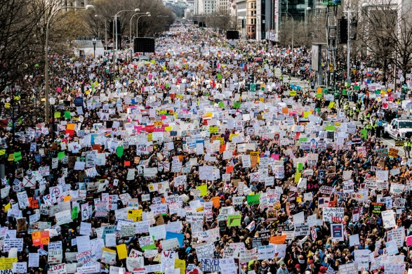
March for Our Lives

On 24 March, it was estimated that 800,000 joined the March for our Lives demonstration in Washington which was organized by Parkland students calling for gun control. Many more joined similar demonstrations throughout the USA and across the world.
Photo: Michael Nigro / SIPA USA / PA Images

What success did they have?
Despite the success of ‘Never Again’ and the ‘March for our Lives’, political developments have been limited. The governments of some states did pass laws introducing elements of gun control in the weeks following 14 February 2018, but nothing happened on a national level. President Trump reiterated his support for the National Rifle Association (NRA). He even suggested that teachers should carry arms. In the meantime, 10 people were killed on 18 May at Santa Fe High School in Texas. This was the 23rd shooting in a school in the United States in 2018.

‘I really feel that the atmosphere is changing. These children who have been affected by gun violence are not willing to suffer any more, as seen by the demonstrations held throughout the country – and they won’t give up.’
Po Murray, Campaigner for gun control

Activities:
Research
- Many people in the United States stand firm against any changes in the gun control laws. (They are called the ‘Gun Lobby’). Currently, the 2nd Amendment to the Constitution allows Americans to own and carry guns. Some, therefore, see this as a fundamental right enjoyed by American citizens. These include the NRA (National Rifle Association). For further information about their viewpoints, see: https://home.nra.org/

President Trump has suggested that school teachers should be given guns in order to protect their pupils. Some people believe that this is an effective way of responding to the violence. Others are firmly against the idea. See more information here: www.theguardian.com/commentisfree/2018/feb/22/arm-teachers-trump-nra-gun-safety-plan-why-its-wrong
and www.edweek.org/ew/issues/arming-teachers.html

Anti-gun groups are not as influential in the USA, but they do exist. See: https://www.csgv.org/ (Coalition to End Gun Violence). Since the Parkland massacre, the parents have also launched a campaign to stop gun violence. See: https://www.facebook.com/StandWithParkland.

Discuss
- What do you think about the action taken by the students after the shooting in their school? Was it effective – in the short term/long term?

- Hold a debate in your class. (You will have to imagine that you live in the United States!) Discuss the motion: ‘Ordinary people should be banned from carrying guns unless they have a special license and have been subjected to background checks.’

You can find resources to support you in developing and forming your debate here: www.wcia.org.uk/global-learning/resources/debating-resources/

Respond
- Imagine that you are one of the surviving pupils from the Parkland massacre. Write a blog or report about what happened and how you felt.

- Write a letter to a newspaper giving your opinion about gun crime in schools.

- Draw a picture or create a poster expressing your response to gun crime. You could do this individually or as a class. Remember to use the hashtag #heddwch2019 and to further share your images on social media. You can send a copy of your picture/poster to the Urdd using heddwch@urdd.org.

Act
- You can send a message of support to the Parkland families here: www.prod.facebook.com/StandWithParkland/

- What about creating a video message of support to be sent to Parkland? Remember to use the hashtag #heddwch2019. You can send a copy of the video the Urdd is using heddwch@urdd.org.

For inspiration, see the following film about Dunblane: www.facebook.com/watch/?v=675622949496051

