Case Study 4
Recruitment of Child Soldiers
(Secondary)

NB: Some of the online material connected to this theme is sensitive in nature. Caution is therefore advisable if asking pupils to research this theme.

What’s happening?
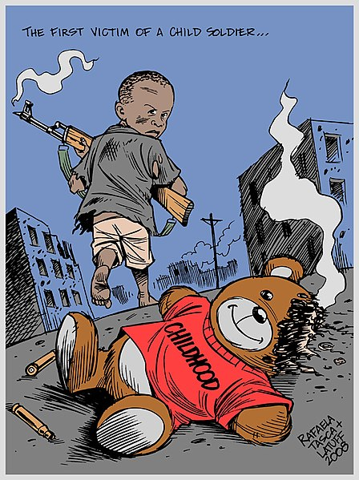
It is estimated that about 250,000 children take part in armed conflict in countries across the world, with 40% of them being girls. Many of them are recruited by force – e.g. kidnapped from their homes or schools. Others join armed forces due to hunger – in the hope that they will be fed regularly.
It’s easier to deal with children than adults. It’s easier to manipulate them and force them to follow orders. Many children fight directly. Others are used as cooks, carriers, messengers or spies. They are in danger of being physically and sexually abused and of suffering mental abuse due to what they see. If they escape, they are not always accepted back by their communities.
Wikimedia Commons

Grace, South Sudan:
When war broke out in South Sudan, Grace had to flee with her mother and younger sister. They were working in the garden when 5 armed men came by and kidnapped them. In the camp, Grace had to fetch water and firewood. She was beaten if she didn’t work quickly enough. They were forced to beat anyone who refused to undertake military training. Grace wasn’t sexually abused because she was quite young at the time (10 years old) but that happened to many older girls. Grace and her family had to remain in the camp for several months until a peace treaty was signed. She was then able to return home.

Grace has now been helped by Child Soldiers International which had enabled her to re-integrate into the community and return to school. She dreams of becoming a doctor. Grace is fortunate. Many of girls who are captured by soldiers live on the fringes of society as they aren’t accepted back by their communities.

Activities:
Research
There is further information about child soldiers here:
- Child Soldiers International: www.child-soldiers.org/who-are-child-soldiers
- Grace’s full story: www.child-soldiers.org/news/life-in-an-armed-group-if-i-didnt-do-it-they-could-kill-me
- Peace Direct: www.peacedirect.org/child-soldiers/
- ‘Child Soldiers’ – video: www.youtube.com/watch?v=6sFi5c7uGB4
- ‘The Difficult Journey Home’ – animation about Justine from the Congo: www.child-soldiers.org/news/what-the-girls-say-the-difficult-journey-home
What does international law have to say? For a summary of the situation, see: www.child-soldiers.org/international-laws-and-child-rights

Discuss
Some questions to discuss:
- What rights have children who are recruited to armies been deprived of?

- Are people generally aware of the fact that children are recruited by armies? If not, why is that the case in your opinion?

- Some say that children choose to join armies (and therefore they are responsible for the consequences). From the stories you have seen and read, what is your opinion about this?

- How can we support children who are suffering due to being recruited by armies?

Respond
- Imagine that you have been abducted by the army or an armed group. Write a diary entry or blog describing your feelings and life in the camp where you are kept. How do people treat you? What do you have to do? What have you lost? What are your hopes for the future?

- How about creating a poster or film to share information with others about child soldiers? Remember to use the hashtag #heddwch2019 and to further share your images on social media. You can also share your images with the Urdd using heddwch@urdd.org.

- You could hold an assembly in your school using one of the above videos, and present Grace or Justine’s story. You could hold a collection ‘Child Soldiers International’.

Act
- Every year leading to 12 February (‘Red Hand Day’), the charity Child Soldiers International organize a campaign with schools against the recruitment of child soldiers. This involves printing the red hand template, then drawing a picture in the centre to write a message of support for children across the world who are affected by war.

You can download the template here: www.child-soldiers.org/Handlers/Download.ashx?IDMF=99f07a33-72a2-4e06-9865-70059cb1d183.

How about holding a special assembly in your school, encouraging as many pupils as possible to draw or write on the red hand? You could then create a display to draw pupils’ attention to the problem. After displaying this for a while, you could send the red hands to Child Soldiers International ready for 12 February next year!

- The United Nation’s Optional Protocol on the Rights of the Child (2000) prohibits conscription for children under 18. Due to this protocol, most countries in the world have raised the threshold for recruitment by the armed forces to 18 years old. However, Britain continues to recruit 16 and 17 year olds. What is your opinion about this?

It could be useful for you read the following report by people working in the health service: www.medact.org/wp-content/uploads/2016/10/medact_childrecruitment_17-oct_WEB.pdf
If you feel strongly about this, write to your Member of Parliament asking the Government to raise the threshold for recruitment by the armed forces to 18. You could do that by using the website ‘Write to Them’ www.writetothem.com/

