Peace and Goodwill Message 2019
Assembly for secondary pupils (KS3 and 4)

This year’s message:
The young people who created the Urdd Peace and Goodwill Message 2019 have clear messages to share with the children and young people of Wales and the world.
- They share their sorrow about children who are suffering and being deprived of their right to care and safety due to violence and war.

- They emphasise the importance of the right of children and young people to use their VOICE to express their opinions and feelings, and of adults listening to them and taking action.

Objectives of the Assembly:
This assembly can be used to deliver the Peace and Goodwill Message 2019 to the whole school, and as a base for further activities about the way in which violence affects children and young people, and what we can do about that.
In particular, the assembly:
- Raises awareness of the United Nations Convention on the Rights of the Child (UNCRC), in particular:
  - the right not to suffer harm, to receive care and protection
  - in there is war, children’s right to be safe and not to be forced to become soldiers
  - the rights of children to use their VOICE – to express their opinions and their feelings, to protect others and to campaign

- Raises awareness of what happens to children during war, and how this affects their rights

- Provides the children / young people with the opportunity to listen to the Peace and Goodwill Message 2019

- Encourages the children to respond to the Message creatively, using their voice to support young people who are frightened or are suffering due to violence and war

Preparation:
You will need:
- A copy of the Urdd Peace and Goodwill Message 2019
- A copy of the PowerPoint which accompanies this assembly
- Access to the internet for Slide 4.

The Assembly:

- Slide 2: The United Nations Convention on the Rights of the Child (UNCRC)
- If there is time, outline the UNCRC’s background.
  - The first version of the document was drafted by Eglantyne Jebb almost 100 years ago in order to safeguard the rights of children following the First World War.
  - The final Convention was adopted by the General Assembly of the United Nations in 1989.
  - By now, most countries in the world have signed the Convention, including the UK.
  - Wales was the first nation in the UK to incorporate the Convention as part of common law in 2011.

- Ask the children: ‘Why is the Convention important, in your opinion?’ Invite ideas. Tell them that the Convention clearly sets out what rights all children across the world should have, wherever they live, whatever their race, their gender or their belief.

- Explain that some rights refer to protecting children against damaging things which can prevent them from growing and developing – e.g. violence and war. (Click here to bring the first two points into the slide).

- Fortunately, the Convention also gives children and young people the right to use their VOICE to say what they need. (Click here again to bring in the third point). When they do that, adults should listen to them. We can also use our VOICE to speak and campaign for others, such as children suffering due to violence and war.

- Slide 3: The United Nations Convention on the Rights of the Child (UNCRC)
When there is war, children tend to lose many of their rights. Ask the pupils for ideas: ‘What rights would be difficult to access in times of war?’ (As they respond, click to bring up the answers and the corresponding rights). Discuss for a while if you have time.

- Slide 4: Case Study – Children used as soldiers
(You will need internet access for this slide!)
Watch the video ‘Child Soldiers’ (www.youtube.com/watch?v=6sFi5c7uG). What rights are endangered when children are forced to serve with the army? (e.g. safe home, protection from violence and abuse, education, being able to play.........)

Ask: how would this feel?

- Slide 4: What can young people do against violence?
Fortunately, young people have the right to use their VOICE against violence and abuse, and to speak for others who are suffering.
Using our VOICE can help to create change.

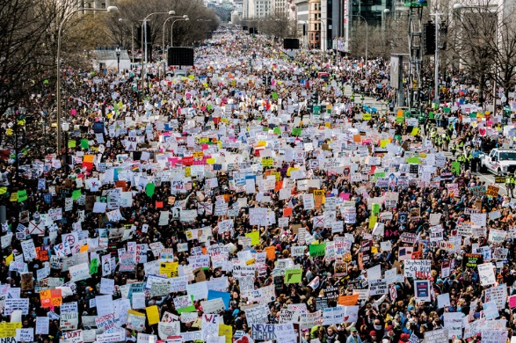
Use the Parkland High School story to show how students used their voice to try to change the law in the United States of America.
On 14 February 2018, Nikolas Cruz, a 19-year-old former pupil of Marjory Stoneman Douglas High School in Parkland, Florida killed 14 pupils and 3 members of staff and injured another 17 in a gun attack.
Shortly after the massacre, a group of pupils came together to launch a campaign. Four days after the shooting, they had a slogan and a hashtag - #NeverAgain. They also had clear aims with regard to gun control and plans for a national demonstration. On 24 March, an estimated 800,000 people joined a ‘March for our Lives’ demonstration in Washington which was organized by Parkland students calling for gun control. Many more joined similar demonstrations throughout the USA and across the world.

- Slide 6: What can we do?
Ask: How do these stories make you feel?

Hearing about children suffering makes us feel sad – but fortunately we have a VOICE, and we can use this voice to speak up and take action for others, including some – such as children who are recruited as child soldiers – who are unable to speak for themselves.

Here are some suggestions about what we can do to help children who live in fear and danger due to violence and war, including children who are recruited as child soldiers. (Click here to bring in the suggestions).

- Slide 7: Urdd Peace and Goodwill Message:
Read the Message.
If possible, ask a group of children to do this.

- Slide 8: Creative Ideas:
Apart from the ideas for action mentioned already, we can also respond creatively to what we have heard today.

Click to show some suggestions – draw pictures, creative writing or create a video, and share images on social media and with the Urdd.

Ask the pupils to hold a minute’s silence and to think about the children throughout the world living in danger and fear, including children who are forced to serve as soldiers.

Tell them that they can have time later on in the day to respond creatively to the assembly and to think about practical things which can be done to support children who are suffering violence and war.

*(NB: For a Case Study and further activities, see the remainder of this pack)

