Patagonia Trip
Urdd Gobaith Cymru

October 2020
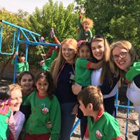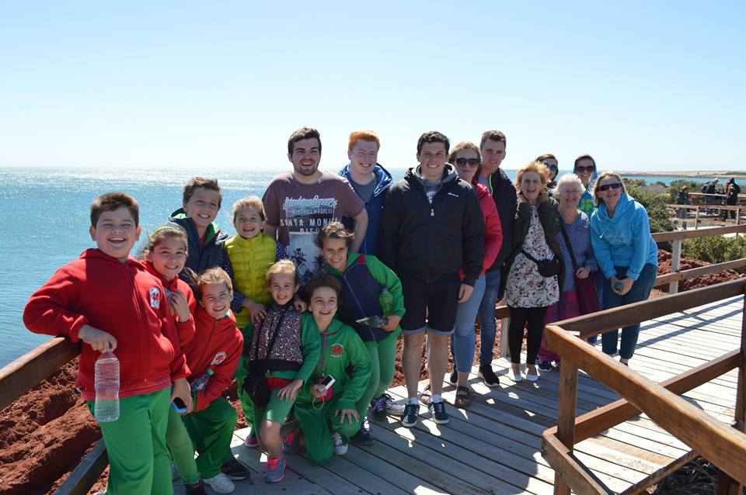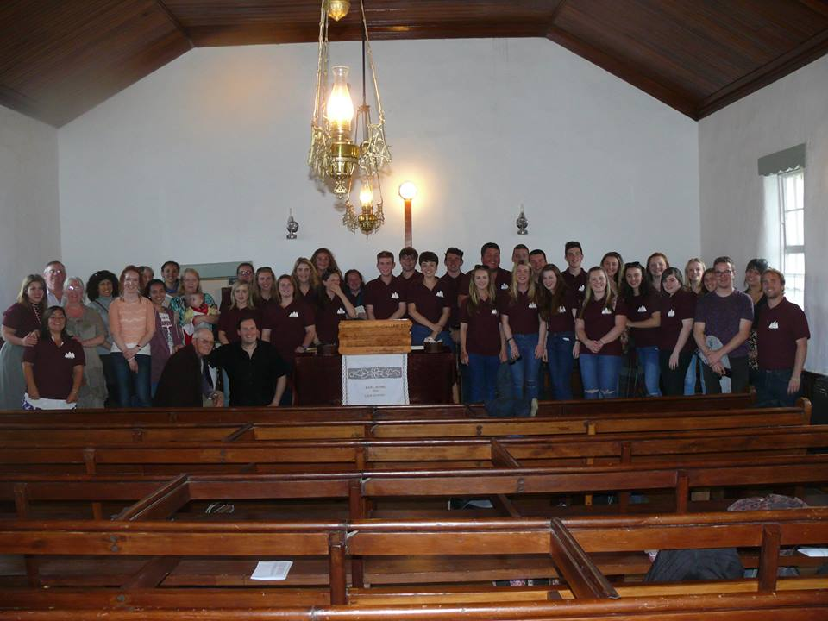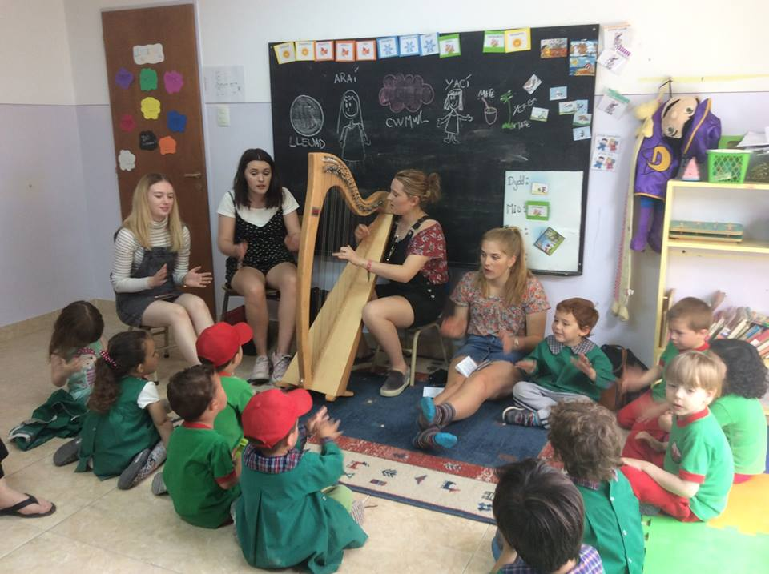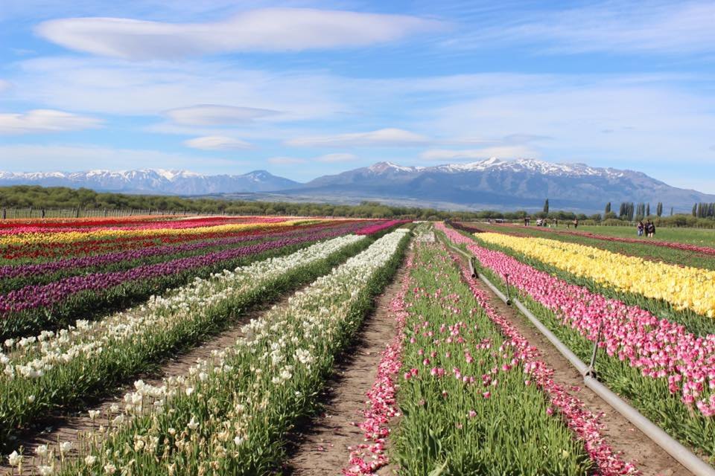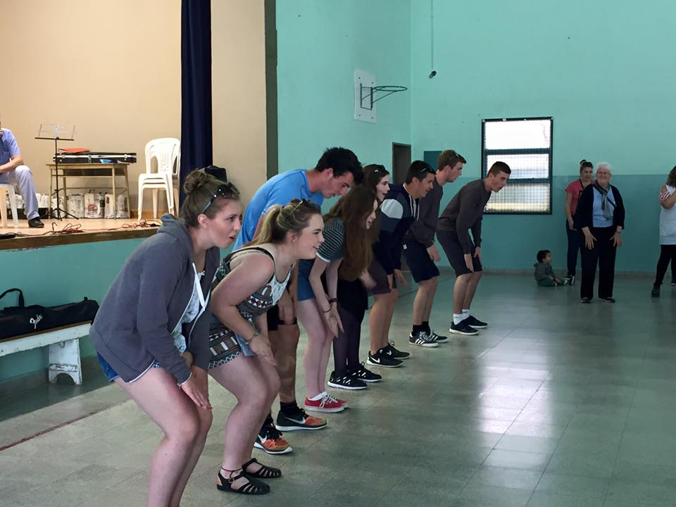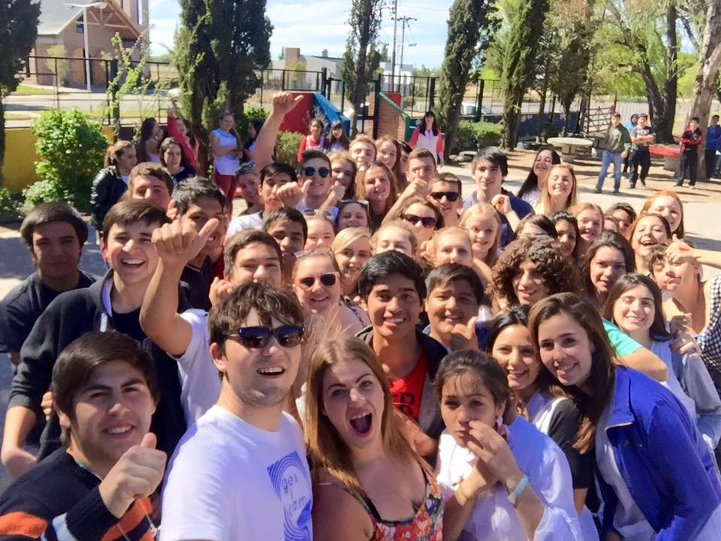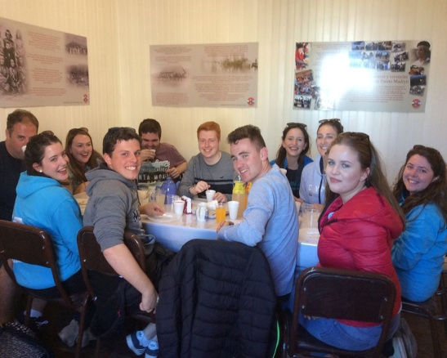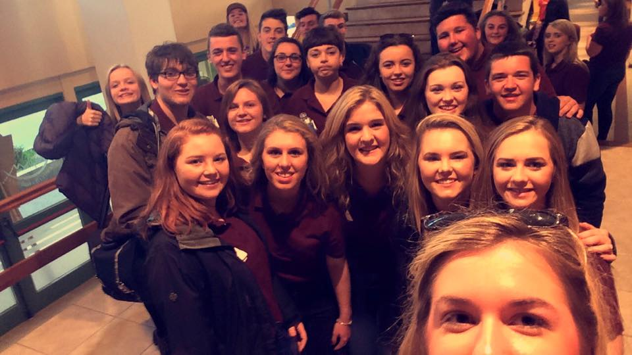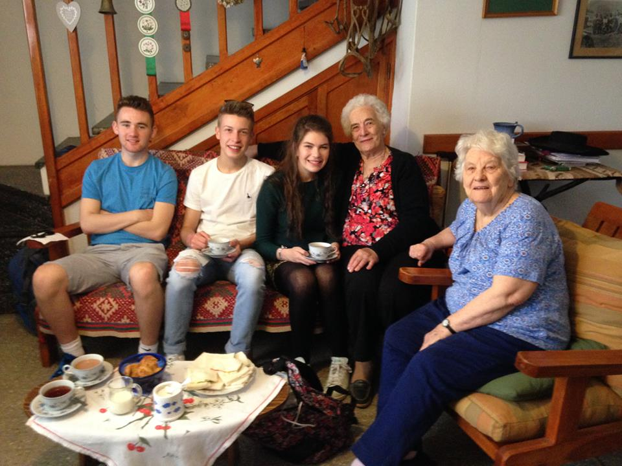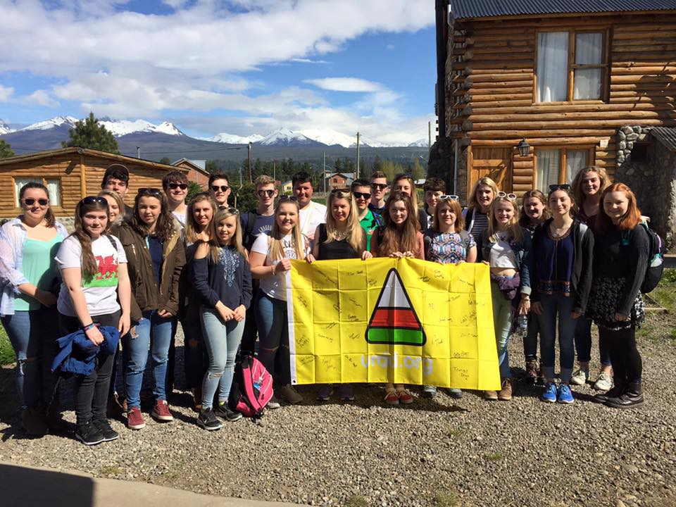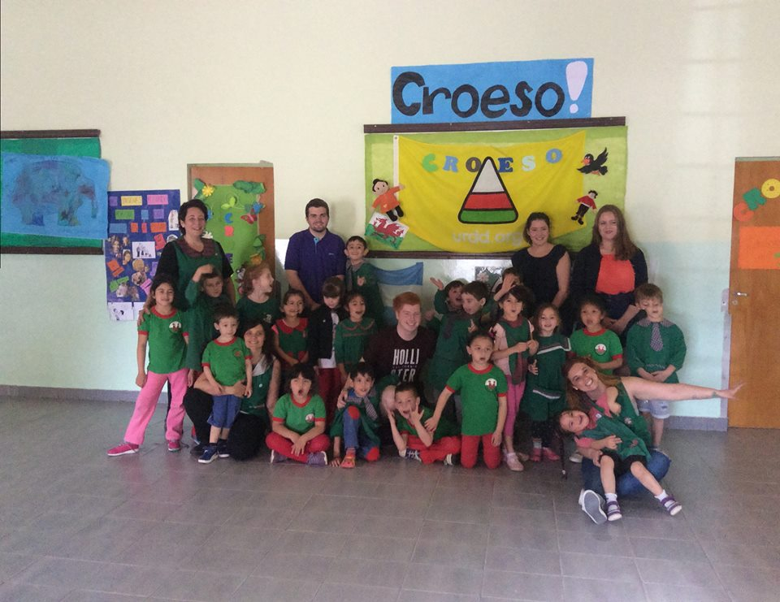

What is the trip?

A chance for 25 young people from all over Wales to volunteer for two weeks at the heart of the communities in Welsh Patagonia.

What will you be doing?

- The locations that you’ll be visiting will include Gaiman, Trelew, Puetro Madryn, Esquel and Trefelin, towns that have very strong connections with Wales.
- Working with children, young people, and residents of the Welsh communities in Patagonia.
- Various volunteering work.
- Taking part in an Argentinian Eisteddfod.
- Meet Welsh speakers at the other side of the world.
- Strengthen the connection between Wales and Patagonia.
- Create friendships for life with young people from all over Wales.

The cost of the trip

The cost of the trip is approxiamately £2,650. You’ll be expected to raise the amount by arranging events / activities for your community / School. This price will vary, depending on the travelling prices and the review of the 2018 trip to Patagonia.

Who can come?

- A student in year 12 or 13.
- Mature people seeking for a new experience.
- Skillfull people that can take part in voluntary work and work with children and young people.
- Enthusiastic people that are driven to rasie the amount of money for the trip.
- People who are available to travel druring the October half term in 2020.

Notes by young people that have attended in the past:

“Its great that I’ve had the chance to experience the thrill of doing something familiar (that is competing), yet in a completely different situation at the other side of the world.”
“Non-stop laughing in the company of amazing people.”
“Hearing the nursery children of Gaiman singing ‘Hen Wlad Fy Nhadau’ is a highlight.”
“Maintaining a games session in Welsh with young people at the other side of the world was a surreal experience.”
“I’ve learnt so much about myself, made new friends, and now respecting the language more.”

Whats the next stage?

You’ll need to fill in the application form by the 7th of October, and if the application is successful you’ll be expected to attend an interview on the 20th of October in either Llangrannog, Glan-Llyn, Caerdydd or Bangor.

Additional information

- There’ll be many chances to meet the young people that will be going on the trip during the year, with support from the Urdd staff whilst raising the money.
- A parents evening will be held for the successful applicants in three different locations – Glan-Llyn, Llangrannog and Caerdydd (dates to be confirmed)
- If you’d like further details in the meantime, contact Eleri Mai on 07500607391 or elerimai@urdd.org

